SYSTEM ARCHITECTURE
LINE / Mobile App / Web → Nginx (Gateway) → Backend Layer (Django + Node.js*) → FastAPI (AI Brain) → Axis Engine + Safety Engine + RAG + ML → PostgreSQL + pgvector + Redis → Celery (Async Processing)

CORE PRINCIPLE
Symptom → Axis Disturbance → Network → Root Cause → Recovery Path → Treatment → Outcome → Learning

FRONTEND LAYER
Web App (Doctor + Admin + LIFF)
Use: Next.js
- Doctor dashboard
- Admin panel
- LINE LIFF (embedded web app)
- SEO + fast rendering
Backend Design
Django (Primary Backend)
- Core business logic
- Patient EMR
- Authentication
- Doctor validation
- API orchestration
BACKEND LAYER
Core Backend:-
Use:- Django + Django REST Framework
Handles:-
- Authentication
- Patient records (EMR)
- Doctor workflows
- API orchestration
- Business logic
AI Backend
Use:- FastAPI
Handles:-
- Axis Engine execution
- AI orchestration
- RAG pipeline
- ML inference
Optional (Scaling / Real-time)
Use:- Node.js
Use only for:-
- Real-time services
- WebSockets
- High concurrency microservices
DATABASE LAYER
Primary Database
PostgreSQL
Stores:-
- Patients
- Axis scores
- Treatments
- Outcomes
Vector Database
Pgvector
Stores:-
- embeddings
- case similarity
Cache / Queue
Redis
Used for:-
- caching
- session
- Celery queue
ASYNC & BACKGROUND JOBS
Task Queue
Celery
Handles:-
- training jobs
- notifications
- report processing
- follow-ups
Monitoring
Flower
REPORTING
- Jinja2 (templates)
- WeasyPrint (PDF generation)

Node.js (Optional / Scaling Layer)
- High-concurrency APIs
- Real-time services (future)
- Event-driven microservices

CHANNEL STRATEGY
LINE & What’s App (Primary Entry)
- Patient communication
- AI interaction
- Engagement
One patient_id across all channels

Web
Next.js
- Doctor dashboard
- Admin panel
All channels connect to one backend + one AI brain
AI BRAIN ARCHITECTURE
Three-Layer AI System
- Axis Engine (Deterministic Core)
- Safety Engine (risk control)
- RAG System (Knowledge + Memory)
- ML Model (prediction)
- LLM Layer (Explanation + Language)

AXIS ENGINE
39-axis model
- Rule-based + weighted scoring
Determines:-
- Axis disturbance
- Root cause
- System relationships
Key Functions
- Symptom → Axis mapping
- Axis scoring (weighted model)
- Dependency graph analysis
- Root cause identification
- Recovery sequence generation
RAG SYSTEM
Retrieves:-
- Case history
- Medical knowledge
- Herbal modules
Stored in:-
Pgvector

CLINICAL SAFETY ENGINE
Red Flag Detection
Immediately detects dangerous conditions:-
- Chest pain + sweating → cardiac risk
- Severe abdominal pain → emergency
- Very high fever → escalation
Action:-
Stop AI flow
Show: “Immediate medical attention required”
Contraindication Engine
Checks:-
- Herb ↔ drug interaction
- Condition ↔ treatment conflict
- Allergy / intolerance
Risk Scoring System
{
"risk_level": "low | medium | high",
"requires_doctor_review": true
}
Confidence & Uncertainty
{
"confidence": 0.78,
"uncertainty": "medium",
"data_quality": "limited"
}
Safety Rule Engine
IF high_risk → mandatory doctor validation
IF low_confidence → request more data

AI LAYER
Uses:-
- Anthropic
- OpenAI
Purpose:-
- Explanation
- Reasoning support
- Natural language output
Core AI Logic (YOUR IP)
- 39-Axis Engine (rule-based)
- Root cause graph
- Treatment sequencing
Voice + OCR
- Whisper API (speech-to-text)
- AWS Textract (report OCR)
Or any other better option like free verson.

39-AXIS SCORING SYSTEM
Formula
Axis Score =
(Symptom × W1) +
(History × W2) +
(Lab × W3) +
(Lifestyle × W4) +
(Temporal × W5)
Root Cause Logic
- Uses dependency graph
- Root cause ≠ highest score
Example:-
Axis 16 → Axis 17 → Axis 10 → Axis 8
Root cause = Axis 16
TREATMENT ENGINE
Recovery Sequence(Step-based recovery) → Treatment Modules(200 modules) →Personalized Plan
Includes:-
- Herbal modules
- Diet
- Lifestyle
Treatment is sequential and system-based.

DOCTOR VALIDATION LAYER
Workflow
AI Output → Doctor Review → Final Plan
Principle
- AI = assistant
- Doctor = final authority

TRAINING & LEARNING SYSTEM
Core Concept
The system learns from outcomes — not just data
Training Loop
Patient Case → AI Suggestion → Doctor Decision → Outcome Tracking → System Learning
Learning Components
Axis Optimization
- Adjusts weights
- Improves mappings
Pattern Learning
Axis combinations(Axis weight optimization) → Best treatment patterns(Treatment ranking) → Pattern learning → RAG memory
Treatment Ranking
- Based on real outcomes
RAG Learning
- Stores successful cases
Local ML Model
- XGBoost / LightGBM
- Predicts treatment success

LOCAL AI SYSTEM
Components
- Axis Engine
- ML Model
- Vector DB
- Training Pipeline
Flow
Data → Features → Model → Prediction → Feedback → Update

LINE & Whats App INTEGRATION
Flow
User → LINE → Django → FastAPI → Response → LINE
Roles
LINE → communication
LIFF → forms + uploads
App → full experience

MOBILE APP STRUCTURE
Features
- Health intake
- Report upload
- AI results
- Treatment tracking
- Progress monitoring

Strategy
LINE = interaction
App = structured experience

TECHNOLOGY STACK
Backend
- Django
- Django REST Framework
- Node.js (optional scaling layer)
- FastAPI
AI
- Claude API
- Whisper API
- AWS Textract
Database
- PostgreSQL
- pgvector
- Redis
Frontend
- Next.js
- React Native
- LINE LIFF
Infrastructure
- AWS
- Docker
- Nginx
DOCTOR DASHBOARD UX
Axis Overview Panel
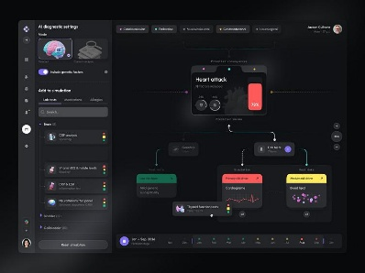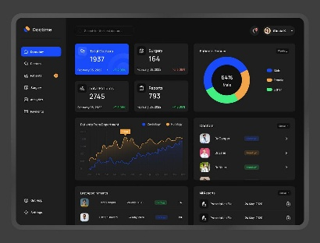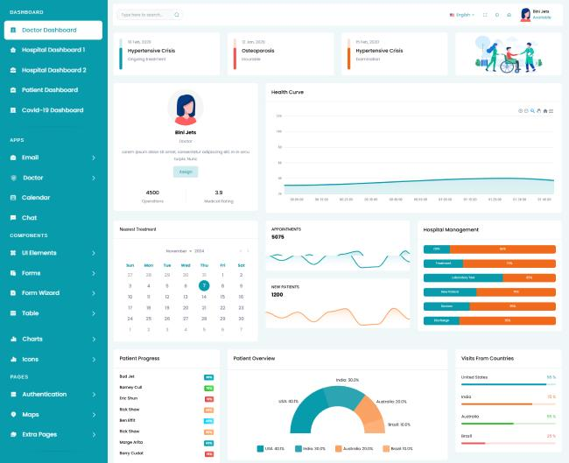
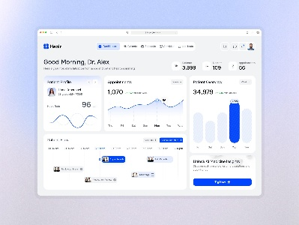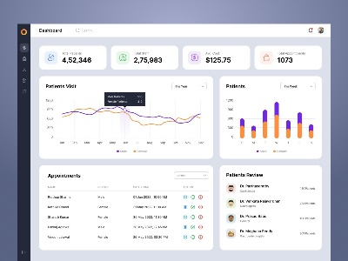
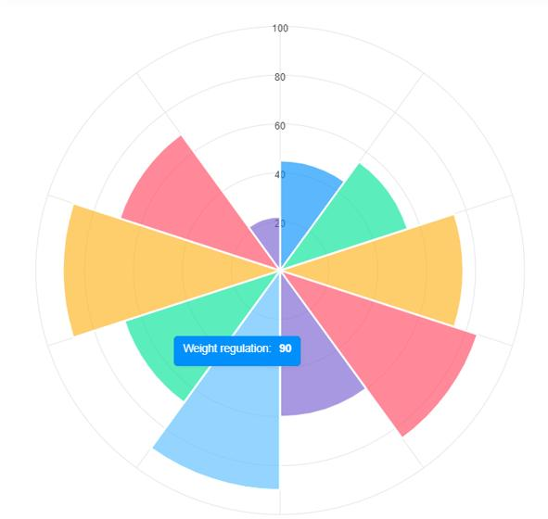
Shows:-
Top affected axes
Severity levels
Visual graph (radial or bar)

CASE SUMMARY PANEL
- Patient history
- Key symptoms
- Risk level
- AI confidence
AI REASONING PANEL
Shows:-

- “Why this axis is selected”
- “Why this treatment is suggested”
TREATMENT PANEL
- Recovery steps
- Modules selected
- Editable by doctor
PROGRESS PANEL
- Improvement graph
- Axis score change
- Outcome tracking
SAFETY PANEL
- Red flags
- Contraindications
- Alerts
ACTION PANEL
Doctor can:-
- Approve
- Modify
- Reject
- Add notes
UX PRINCIPLES
- Visual
- Explainable
- Editable
- Fast

FINAL SYSTEM FLOW
Patient Input → Axis Engine → Safety Engine →Root Cause Detection → RAG +ML+ AI → Treatment Draft → Doctor Dashboard (UX) → Doctor Validation → Patient Output → Feedback → Learning

INTEGRATION FLOW
LINE / Mobile App / Web → Django (Core Backend) → FastAPI (AI Brain) → Axis Engine + RAG + ML → Database (PostgreSQL + pgvector) → Celery (background jobs)

WHAT IS Our “39-AXIS MODEL
It is a clinical reasoning framework
It’s Not a disease list or a symptom checker
The 39 axes represent the key biological systems/functions of the human body that can go out of balance.
Your system asks:-
Which body systems (axes) are disturbed, and how are they connected?
WHAT ARE THESE “AXES”?
Each axis = one functional system
Examples :-
- Digestion
- Microbiome
- Inflammation
- Detox / Liver
- Hormones
- Nervous system
- Sleep
- Mitochondria (energy)
Total = 39 such systems
HOW OUR SYSTEM USES THE 39 AXES?
STEP 1:- INPUT
Patient ll gives:-
- Symptoms
- History
- Reports
STEP 2:- AXIS MAPPING
System converts symptoms → axes

Example:-
- Bloating → Digestion + Microbiome
- Fatigue → Energy + Inflammation
STEP 3:- AXIS SCORING
Based on:-
- Symptoms
- History
- Labs
- Lifestyle
- Time

STEP 4:- NETWORK ANALYSIS
System checks:-
How axes are connected
Example:-
Digestion → Microbiome → Inflammation → Energy → Sleep
STEP 5:- ROOT CAUSE DETECTION
The first problem in the chain = root cause
Visual chain:-
Digestion → Microbiome → Inflammation → Energy → Sleep
Doctor sees:-
Cause → effect
Not just symptoms
Example:-
- Root = Digestion
- Others = downstream
STEP 6:- RECOVERY PATH
System builds order:-
- Fix digestion
- Fix microbiome
- Reduce inflammation
- Improve energy
- Improve sleep
STEP 7:- TREATMENT PLAN
Based on axes:-
- Herbal modules
- Diet
- Lifestyle
STEP 8:- EXPLANATION
AI explains:-
“Your digestion system is the root cause, which affected your gut bacteria and led to inflammation and fatigue.”

STEP 9:- LEARNING
System tracks:-
- What worked
- What didn’t
Improves over time

SIMPLE FLOW
Symptoms → Axis Mapping → Axis Scores → Root Cause → Recovery Path → Treatment

